Session 5 Administering Accounts and Resources (Theory)

Objectives
After completing this module, you will be able to:
- Describe the Windows Server 2003 environment.
- Log on to a computer running Windows Server 2003.
- Install and configure the administrative tools.
- Create an organizational unit.
- Move objects within a domain.
Computer roles in a Windows Server 2003 environment

Servers play many roles in the client/server networking environment. Some servers are configured to provide authentication, and others are configured to run applications. Some provide network services that enable users to communicate or find other servers and resources in the network. As a systems administrator, you are expected to know the primary types of servers and what functions they perform in your network.

Domain controller (Active Directory)
Domain controllers store directory data and manage communication between users and domains, including user logon processes, authentication, and directory searches. When you install Active Directory on a computer running Windows Server 2003, the computer becomes a domain controller.
Note
In a Windows Server 2003 network, all servers in the domain that are not domain controllers are called member servers. Servers not associated with a domain are called workgroup servers.
File server
A file server provides a central location on your network where you can store and share files with users across your network. When users require an important file such as a project plan, they can access the file on the file server instead of passing the file between their separate computers.
Print server
A print server provides a central location on your network where users can print. The print server provides clients with updated printer drivers and handles all print queuing and security.
DNS server
Domain Name System (DNS) is an Internet and TCP/IP standard name service. The DNS service enables client computers on your network to register and resolve DNS domain names. A computer configured to provide DNS services on a network is a DNS server. You must have a DNS server on your network to implement Active Directory.

Application server
An application server provides key infrastructure and services to applications hosted on a system. Typical application servers include the following services:
- Resource pooling (for example, database connection pooling and object pooling)
- Distributed transaction management
- Asynchronous program communication, typically through message queuing
- A just-in-time object activation model
- Automatic Extensible Markup Language (XML) Web Service interfaces to access business objects
- Failover and application health detection services
- Integrated security
Microsoft Internet Information Services (IIS) provides the tools and features necessary to easily manage a secure Web server. If you plan to host Web and File Transfer Protocol (FTP) sites with IIS, configure the server as an application server.

Terminal server A terminal server provides remote computers with access to Windows-based programs running on Windows Server 2003, Standard Edition; Windows Server 2003, Enterprise Edition; or Windows Server 2003, Datacenter Edition.
With a terminal server, you install an application at a single point on a single server. Multiple users then can access the application without installing it on their computers. Users can run programs, save files, and use network resources all from a remote location, as if these resources were installed on their own computer.

Workgroups and Domains
Networks come in two forms: workgroups and domains. When a computer is configured for networking, a computer name must be supplied along with a workgroup or domain name. It is important to maintain a standard naming scheme. Standardizing the naming scheme can make it much easier to locate network resources. A naming scheme makes sure all of our computers have unique names. Workgroups and domains should be given names, which identify either location or function (a combination can also be used). An example is to name all workgroups according to department; for example, ACCOUNTING, MARKETING, and HR. Inside the workgroups, we need naming standards to specify each machine. Example is to name the computers the job title of the user; for example, RECEIVABLES, PAYABLES, BILLING, and so on. It is important to remember that workgroups, domains, and computers must have names that are unique on the network.

Workgroups
A workgroup is a group of PCs networked together. Workgroups help organize computers in a peer-based network according to department or function. Networks can have a large number of workgroups. Each computer can be a member of one workgroup. With Windows XP, these can be found under My Network Places.

Domains
A domain is a group of PCs that are part of a network and share a common directory database in a central file server. A domain is administered as a unit with common rules and procedures. Each domain has a unique name.

- A domain is a collection of computers, defined by an administrator, that share a common directory database. A domain has a unique name and provides access to the centralized user accounts and group accounts maintained by the domain administrator.

An Active Directory domain is a collection of PCs defined by the administrator of a network.
These PCs share a common directory database, security policies, and security relationships with other domains. An Active Directory domain provides access to the centralized user accounts and group accounts maintained by the domain administrator. An Active Directory is made up of one or more domains, each of which can span more than one physical location.
A Domain Name System (DNS) domain is any tree or subtree within the DNS namespace.

User Accounts
A user account is a record that consists of all the information that defines a user to the network.
This includes the user name and password required for the user to log on, the groups in which the user account has membership, and the rights and permissions the user has for using the PC and the network, and accessing the network resources.

Types of user accounts
Computer administrator account: The computer administrator account is intended for someone who can make system wide changes to the computer, install software, and access all non-private files on the computer. Only a user with a computer administrator account has full access to other user accounts on the computer.
A user with a computer administrator account:
• Can create and delete user accounts on the computer.
• Can change other users account names, pictures, passwords, and account types.
• Cannot change his or her own account type to limited unless there is at least one other user with a computer administrator account. This ensures that there is always at least one user with a computer administrator account on the computer.
• Can manage his or her network passwords, create a reset password disk, and set up his or her Account.

Limited account: The limited account is intended for someone who should be prohibited from changing most computer settings and deleting important files.
A user with a limited account:
• Generally cannot install software or hardware, but can access programs that have already been installed on the computer.
• Can change his or her account picture and can also create, change, or delete his or her password.
• Cannot change his or her account name or account type.
• Can manage his or her network passwords, create a reset password disk, and set up his or her account to use a .NET Passport.

Guest account: The guest account is intended for use by someone who has no user account on the computer. There is no password for the guest account, so the user can log on quickly to check e-mail or browse the Internet. A user logged on to the guest account:
• Cannot install software or hardware, but can access applications that have already been installed on the computer.
• Cannot change the guest account type.
• Can change the guest account picture.

What Is a Directory Service?

Introduction
As a user logged on to a network, you might need to connect to a shared folder or send a print job to a printer on the network. How do you find that folder and printer and other network resources?

Definition
Directory services
A directory service is a network service that identifies all resources on a network and makes that information available to users and applications.
Directory services are important, because they provide a consistent way to name, describe, locate, access, manage, and secure information about these resources.
When a user searches for a shared folder on the network, it is the directory service that identifies the resource and provides that information to the user.
Active Directory is the directory service in the Windows Server 2003 family. It extends the basic functionality of a directory service to provide the following benefits:

􀂄 DNS integration
Active Directory uses DNS naming conventions to create a hierarchical structure that provides a familiar, orderly, and scalable view of network connections. DNS is also used to map host names, such as microsoft.com, to numeric TCP/IP addresses, such as 192.168.19.2.

􀂄 Scalability
Active Directory is organized into sections that permit storage for a very large number of objects. As a result, Active Directory can expand as an organization grows. An organization that has a single server with a few hundred objects can grow to thousands of servers and millions of objects.

􀂄 Centralized management
Active Directory enables administrators to manage distributed desktops, network services, and applications from a central location, while using a consistent management interface. Active Directory also provides centralized control of access to network resources by enabling users to log on only once to gain full access to resources throughout Active Directory.

􀂄 Delegated administration
The hierarchical structure of Active Directory enables administrative control to be delegated for specific segments of the hierarchy. A user authorized by a higher administrative authority can perform administrative duties in their designated portion of the structure. For example, users may have limited administrative control over their workstation’s settings, and a department manager may have the administrative rights to create new users in an organizational unit.

Active Directory Terms
The logical structure of Active Directory is flexible and provides a method for designing a hierarchy within Active Directory that is comprehensible to both users and administrators.

Logical components
The logical components of the Active Directory structure include the following:

- Domain. The core unit of the logical structure in Active Directory is the domain. A domain is a collection of computers, defined by an administrator, that share a common directory database. A domain has a unique name and provides access to the centralized user accounts and group accounts maintained by the domain administrator.

- Organizational unit. An organizational unit is a type of container object that you use to organize objects within a domain. An organizational unit may contain objects, such as user accounts, groups, computers, printers, and other organizational units.

- Forest. A forest is one or more domains that share a common configuration, schema, and global catalog.

- Tree. A tree consists of domains in a forest that share a contiguous DNS namespace.
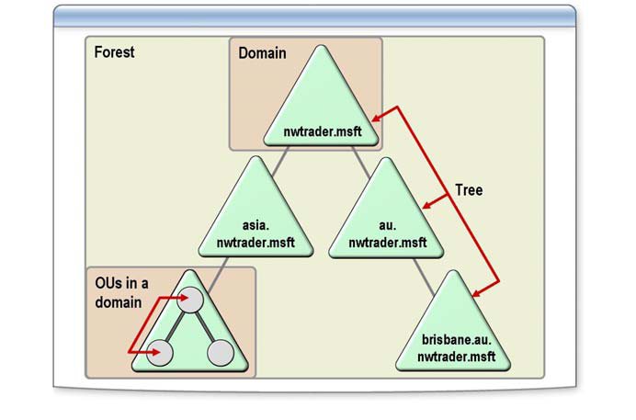

Administrative tools
Administrative tools enable network administrators to add, search, and change computer and network settings and Active Directory objects. You can install the administrative tools for managing a Windows Server 2003 environment on computers running Microsoft Windows XP Professional and Windows Server 2003 to remotely administer Active Directory and network settings.
Some of the more commonly used tools include the following:
- Active Directory Users and Computers
- Active Directory Sites and Services
- Active Directory Domains and Trusts
- Computer Management
- DNS
- Remote Desktops

